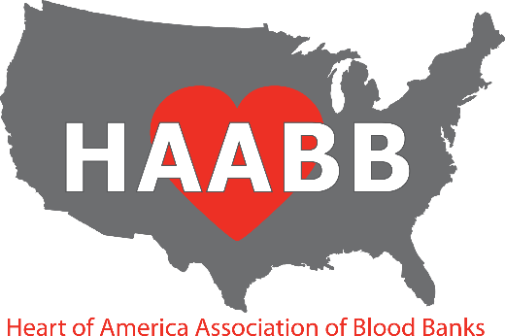

2026 Fall Meeting
September 23, 2026

PRELIMINARY PROGRAM

AM Session
07:30 – 08:30 Registration
08:30 – 08:45 ● Welcome—Michelle Burgin, HAABB President
08:45 – 10:00 ● Case Study: A Colorful Solution to FDA Reportable Events
- Shay Jones, MLS(ASCP) ^{CM}, BB^{CM}

- Antibody Adventures: A Donor Case Series
- Jennifer Jung, MLS(ASCP), SBB^{CM}

10:00 – 10:30 Vendor Exhibits (Break)
10:30 – 11:45 ● Case Study: Spill the Beans: A Tale of Polyagglutination
- Gina Folk, MSHS, MLS(ASCP)^{CM}, SBB^{CM}

- Whole Blood Usage Panel
- Carrie Easley, MSTM, MLS (ASCP) SBB^{CM}
- David Harsh
- Shay Jones MLS(ASCP)^{CM}, BB^{CM}

11:45-1:00 Lunch
PM Session

1:00 – 2:15 ● Mysteries in Labor and Delivery
- Gino Gaytano, MLS(ASCP) SBB^{CM}

● Case Study: Troubleshooting transfusion needs in patients with sickle cell disease undergoing transformative treatment
- Dr. Suzie Thibodeaux

2:15 – 2:45 Vendor Exhibits (Break)
2:45 – 4:00
- RH you Ready? Overview of a Blood Group System Through Cases
- Lynsi Rahorst, MHPE, MLS(ASCP), SBB^{CM}

- Viscoelastic testing in the Operating Room
  - Jonathan K. Zoller, MD
Drury Inn & Suites near Forest Park

2111 Sulphur Avenue

St. Louis, MO 63139

Telephone: (314) 646-0770

Please make your reservations by August 30, 2026 to receive the group rate. Reservations made after this date will be subject to prevailing rates and availability. Make reservations online at https://www.druryhotels.com/bookandstay/newreservation/?groupno=10186575

Reservations may also be made by calling 1-800-325-0720 and referring to your group number 10186575.

At Drury Hotels, we know you have enough to worry about when traveling. In addition to the great rate, our generous amenities will brighten your group’s day and make your journey easier.

- Complimentary Hot Breakfast - Enjoy scrambled eggs, oatmeal, fresh fruit, potatoes, pastries, the all-important coffee and more. Hot, fresh, and, best of all, free. Free hot breakfast is served daily from 6-9:30 a.m. on weekdays and 7-10 a.m. on weekends.

- Complimentary Evening Drinks and Snacks* - Join us from 5:30 p.m. – 7:00 p.m. every evening to enjoy complimentary snacks and cold beverages at our 5:30 Kickback®. The Hotel features a rotating menu of snacks, beer, wine, mixed drinks and soft drinks.

- Complimentary Wi-Fi Throughout the Hotel - Get the score, check social networks or email family members in the hotel!

- On-Site Facilities - Take advantage of the business center, fitness center or pool while away from home. Print boarding passes, finish a presentation or check e-mail in the Hotel’s business centers.

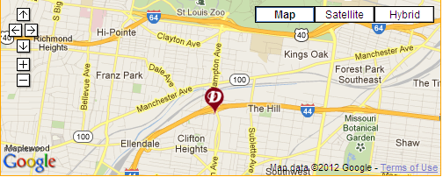

Directions:  Traveling East On I-44:  Take Exit #286  Turn Right On Hampton Ave  Turn Right On Wilson Ave  Turn Left On Sulphur Ave | Traveling West On I-44:  Take Exit #286  Turn Left On Hampton Ave  Turn Right On Wilson Ave  Turn Left On Sulphur Ave
HAABB 2026 Fall Meeting Registration Information

Registration Options & Fees:
There are two available sessions: Wednesday AM and Wednesday PM. Registration fees are as follows:

Registration Type Cost per Session After 09/09/2026

Individual $70 $85

Institutional $55* $70

Resident $55 $70

CLS Student $30 $45

*Institutional Membership requires an additional $35 fee.
______________________________________________________________________________________________________

Methods of Registration:
Mail: Complete the registration form and mail it along with payment to the address below. Please make checks
payable to HAABB.

Diana Moroney, HAABB Treasurer
7414 Kirby Knowle Ct.
Columbia, MO
65203

Online: Register and pay via credit card at www.haabb.org
______________________________________________________________________________________________________

Registration Form Instructions:
The registration form is divided into two sections:

- Individual / Resident / Student Attendees
This section is for individuals registering independently, including residents and CLS students eligible for discounted rates.
- Individual membership is included with registration and begins upon payment receipt.
- Membership is valid through April 1, 2027.

- Institutional Attendees
This section is for Institutions registering multiple employees to attend the HAABB Annual Meeting at a discounted rate
- Institutional Membership Fee: $35
- Institutions may register an unlimited number of employees under one membership
- Session fees must be paid per person, per session
- Membership is valid from payment receipt through April 1, 2027

Cancellation & Refund Policy: To receive a full refund, cancellation requests must be sent by September 21, 2026 to Diana Moroney, HAABB Treasurer, at Diana.Moroney@redcross.org. Registrations cancelled after September 21, 2026 are non-refundable.

MEETING DETAILS:

Lunch:
All session attendees will receive a complimentary lunch, courtesy of the HAABB Board of Directors. Please indicate your preference for a vegetarian option on the registration form.

Parking: Free parking is available.
HAABB 2026 Fall Meeting Registration Form
(Please, see form instructions prior to completing)

INDIVIDUAL / STUDENT / RESIDENT ATTENDEE INFORMATION

Attendee Name: __________________________________ Institution: ________________________________

Institution Address: ___________________________________________________________________________

Email*: _________________________________ Phone: ___________________________________________
*Your email will be used for meeting communications and may be shared with vendor exhibitors.

Check the sessions you will be attending: Wed AM Wed PM Vegetarian Lunch Requested

Attendee Type Cost per Session Cost after 9/9/2026 # of Sessions Total fee

INDIVIDUAL $70 $85 __________ $________
RESIDENT $55 $70 __________ $________
STUDENT $30 $45 __________ $________

INSTITUTIONAL MEMBERSHIP ATTENDEE INFORMATION

Institution Name: _________________________ Primary Contact Person ________________________________

Institution Address: ___________________________________________________________________________

Email*: ___________________________________________ Phone: __________________________________
*Email may be used for meeting communications and shared with vendor exhibitors.

Please list each attendee with their credentials and session selections. Add asterisk * next to the name if a vegetarian lunch is requested.

Attendee Name Credentials Wed AM Wed PM
1.__________________________________________________________________

2.__________________________________________________________________

3.__________________________________________________________________

4.__________________________________________________________________

5.__________________________________________________________________

Registration Fees:

Cost of Institutional Membership = $35

Cost of Sessions = $55 ($70 after 9/9/2026) x # of Sessions = $____________

Total Cost = $35 + Cost of Sessions = $___________

