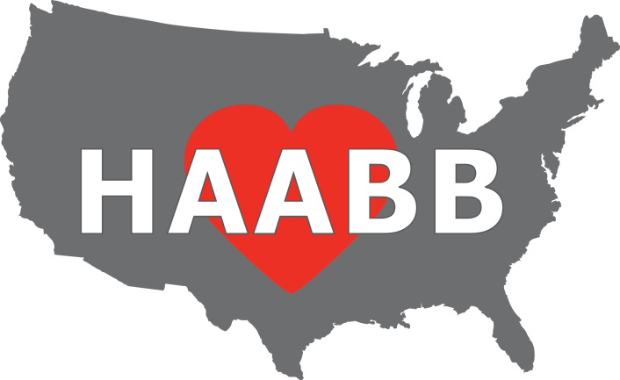

Heart of America
Association of Blood Banks

57th Annual Meeting

Wednesday & Thursday

May 8 & 9, 2024

PRELIMINARY
PROGRAM

Argosy Casino, Hotel & Spa

777 NW Argosy Casino Pkwy

Riverside, MO 64150

Visit us
www.HAABB.org or find us on

57th Spring Meeting Speaker Program

Wednesday, May 8, 2024
7:30 – 8:40 Registration located outside of meeting rooms

8:40 – 11:30 AM Session
- Case Study: Anti-G
  - Misty Huddleson, MLS(ASCP)^{CM}, American Red Cross, Lenexa, KS
- CD38 & CD47: Blood Bank’s Kryptonite
  - Shay Jones, MLS(ASCP)^{CM}, BB^{CM}, University of Kansas Health System, Kansas City, KS
- Case Study: Disseminated Histoplasmosis
  - Laci Mallory, Stormont Vail Health, Topeka, KS
- Case Study: Unusual course of Hemolytic Disease of Newborn
  - Dr. Music-Aplenc, Children’s Mercy Hospital, Kansas City, MO
- Case Study: Pre-Op Anemia
  - Carrie Easley MLS (ASCP)SBB^{CM}, Stormont Vail Health, Topeka, KS
11:30 – 1:00 Lunch and Opening of Vendor Exhibits
1:00 – 4:00 PM Session
- Case Study: Just When You Thought It Was Safe to Go Back in The Water – A Case of Unidentified Reactivity
  - Shay Jones MLS(ASCP)^{CM}, BB^{CM}, University of Kansas Health System, Kansas City, KS
- Exploring the Evolving World of Biotherapies
  - Dr. Suzanne Thibodeaux, Washington University School of Medicine, St. Louis, MO
- Case Study: Exchange Transfusion for Methemoglobin
  - Mary Signaigo, MLS(ASCP), Mercy Hospital St. Louis, St. Louis MO
- Apheresis
  - Dr. Daniel R. Walker, University of Missouri School of Medicine, Columbia MO

4:00 – 6:00 Reception / Vendor Exhibits

Thursday, May 9, 2024

7:30 – 8:30 Registration

8:30 – 11:30 AM Session
- Case Study: Donath Landsteiner and Paroxysmal Cold Hemoglobinuria
  - Kelly Winkhart, BB(ASCP), SBB^{CM}, Community Blood Center of Kansas City
- MLS Career Advancement, Keeping Staff Engaged
  - Brenna Ildza, St. Luke’s Hospital, Kansas City, MO
- Case Study: After the emergency: a case for the utilization of antibody registries and red cell exchange in the management of incompatible transfusions
  - Dr. Keenan Hogan, University of Kansas Medical Center, Kansas City, KS
- Implementing a Mass Casualty Incident (MCI) Protocol
  - Melissa Wadsworth MLS(ASCP)^{cm}SBB, The University of Kansas Health System, Kansas City, KS, Co presented with David Harsh, Community Blood Center of Kansas Cityi
11:30-1:00 Lunch and Vendor Exhibits
1:00 - 1:15 HAABB Annual Business Meeting
1:15 – 4:00 PM Session
- Scianna Blood Group System and Case Study
  - Gina Folk MSHS, MLS^{cm} SBB^{cm,} Community Blood Center of Kansas City
  - Aaron J. Gottschalk, PhD, Community Blood Center of Kansas City, NCBGG
  - Brian Easley MLS (ASCP)^{CM}SBB^{CM} , St. Luke’s Hospital, Kansas City, MO
- Case Study: Auto Anti-Jkª in Pregnancy
  - Mary Signaigo, MLS(ASCP), Mercy Hospital St. Louis, St. Louis, MO
- Impact of Platelet ABO compatibility and Irradiation on Transfusion Reaction Rates
  - Dr. Keenan Hogan, University of Kansas Medical Center, Kansas City, KS
2024 HAABB ANNUAL MEETING REGISTRATION
REGISTRATION INFORMATION

There are 4 sessions available: Wednesday AM, Wednesday PM, Thursday AM and Thursday PM. The costs associated with each type of registration are as follows:

Individual: $65 per session After 4/24/2024, each session price will increase to $70

Institutional: $60 per session The Institutional Membership cost is an additional $35.
After 4/24/2024, each session price will increase to $65

CLS Student: $25 per session After 4/24/2024, each session price will increase to $30

Resident: $50 per session After 4/24/2024, each session price will increase to $55
______________________________________________________________________________________________________

METHODS OF REGISTRATION:
Mail—Complete and mail the registration form including payment to the following address. Make check payable to HAABB. Brian Easley, HAABB Treasurer
5402 NW 93rd St.
Kansas City MO 64154
Online—Register online at www.haabb.org to make payment via credit card. ______________________________________________________________________________________________________

REGISTRATION FORM INSTRUCTIONS: The registration form is divided into two sections: individual/student/resident attendees and institutions requesting to send multiple attendees. Below describes each section.

Individual/Student/Resident Attendees Section: This section is for the individual or student seeking to attend the meeting. For the individual, HAABB individual membership is included in the price of the sessions. By attending, membership is obtained. Membership will begin upon receipt of payment and will expire April 1, 2025. This section should also be used for CLS students and Residents wishing to attend the meeting at a discounted student session rate.

Institutional Attendees Section: This section is for institutions seeking to have multiple employees attend the meeting at a discounted session rate. HAABB institutional membership cost is $35. There is no limit to the number of employees that may attend when an institutional membership is obtained. The session fee must be paid per person per session attended. Membership will begin upon receipt of payment and will expire April 1, 2025.

NOTE: If you need to cancel your registration, please send an email to Brian Easley, HAABB Treasurer, atbeasley@saint-lukes.org, by April 24, 2024, to receive a full refund. After April 24, 2024, the registration fee is non-refundable.
______________________________________________________________________________________________________

MEETING DETAILS:

Lunch:
All registrants are invited to enjoy lunch compliments of the HAABB Board of Directors! Lunch will be provided to the registrants on the day of the session(s) attended. If you desire a VEGETARIAN lunch, please check the box on the registration form.

Parking: Parking is Free.

2024 HAABB ANNUAL MEETING REGISTRATION
INDIVIDUAL / STUDENT / RESIDENT ATTENDEE INFORMATION

Attendee Name: __________________________________ Institution: ________________________________

Institution Address: ___________________________________________________________________________

Email*: __________________________________ Phone: ___________________________________________
*Email address provided will be used by HAABB for communication regarding meetings and may be shared with vendor exhibitors.

Check the sessions you will be attending: Wed AM Wed PM Thurs AM Thurs PM

VEGETARIAN LUNCH (please check if needed)

INDIVIDUAL: Total Cost = $65 ($70 after 4/24/2024) x # of Sessions = $________________
STUDENT: Total Cost = $25 ($30 after 4/24/2024) x # of Sessions = $________________
RESIDENT: Total Cost = $50 ($55 after 4/24/2024) x # of Sessions = $________________

INSTITUTIONAL MEMBERSHIP ATTENDEE INFORMATION

Institution Name: _________________________ Contact Person _______________________________________

Institution Address: ___________________________________________________________________________

Email*: ____________________________________ Phone: ________________________________________
*Email address provided will be used by HAABB for communication regarding meetings and may be shared with vendor exhibitors.

In the space provided, please include the attendee names, credentials, and which sessions will be attended. If additional space is needed, please attach a separate sheet. There is no limit to the number of attendees that can register when an institutional membership is obtained. Four sessions are available. Each session price is $60 per attendee. The institutional membership cost is an additional $35. After 4/24/2024, each session price will
increase to $65.

Attendee Name Credentials Wed AM Wed PM Thurs AM Thurs PM
1. ___________________________________________
2. ___________________________________________
3. ___________________________________________
4. ___________________________________________
5. ___________________________________________
Please indicate if any of the attendees requires a vegetarian lunch (* by the name)
Cost of Institutional Membership = $35
Cost of Sessions = $60 ($65 after 4/24/2024) x # of Sessions = $____________

Total Cost = $35 + Cost of Sessions = $___________
HOTEL RESERVATIONS

Argosy Casino, Hotel & Spa

777 NW Argosy Casino Pkwy

Riverside, MO 64150
https://www.argosykansascity.com

For reservations, go to Argosykansascity.com before 4/25/2024 to receive the applicable group rate of $109.99++ per night.
Click Book Now, Enter Group code: MH050724
Group name HAABB Annual Spring Meeting, click Select and complete the registration.

