Heart of America Association of Blood Banks

The HAABB is offering a scholarship gift in the amount of $500 to the MLS or MLT student attending an area program who submits the best paper on a Transfusion Medicine topic. We hope that this award will promote an interest in research, development and continuing education in the field of blood banking.

The paper should be 2 – 5 pages, double spaced and should be relevant to today’s blood banking field. Topics can cover technical advances, current trends, experimental work or controversial issues in the fields of blood banking, transfusion medicine, and cellular and gene therapies.

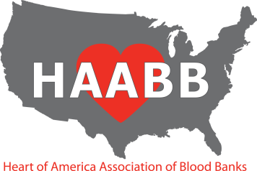
The format of the paper should include Title, Introduction, Discussion, Conclusions and References. Please see the attached rubric which will be used for judging the papers.

Deadline for submission is April 15, 2021. Only the first 10 papers received prior to the deadline will be considered. Visit www.haabb.org to determine if submissions are still being accepted.

The winning paper will be placed on the HAABB website by mid-May 2021. If we are able to hold our Fall meeting in 2021, we would like to display all of the papers that were judged. The other applicants submitting papers considered for the scholarship will receive a $25 gift card. Entries remain the property of HAABB.

Application must arrive by April 15, 2021 to the following:

Emily Coberly, MD

emily.coberly@redcross.org

HEART OF AMERICA ASSOCIATION OF BLOOD BANKS

SCHOLARSHIP APPLICATION FORM

Name_

Address__

City _ State_ Zip Code

Daytime phone Evening Phone _________

Email Address _

SCHOOL/PROGRAM INFORMATION

School/Program _

Program Director/Advisor _

Address _

City _ State_ Zip Code

Daytime phone _ FAX _

Email Address _

